**Postman Testing for a Blog Management System**

**Auth Testing**

* **Register**

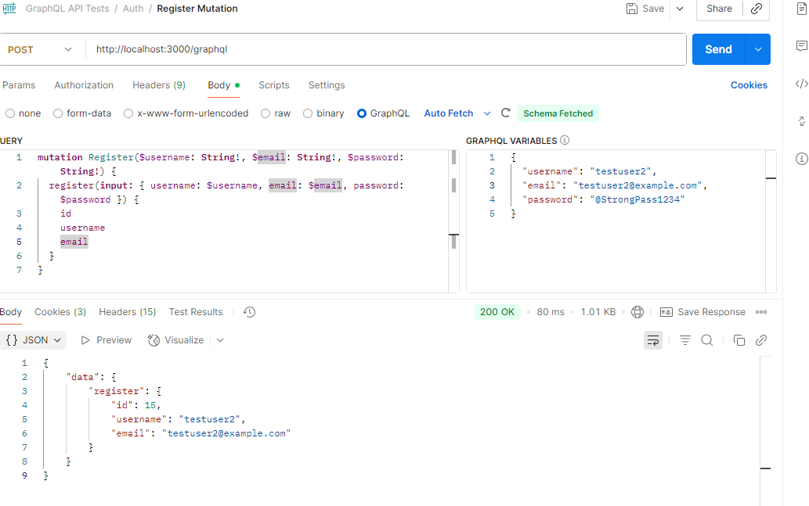

* **Login**

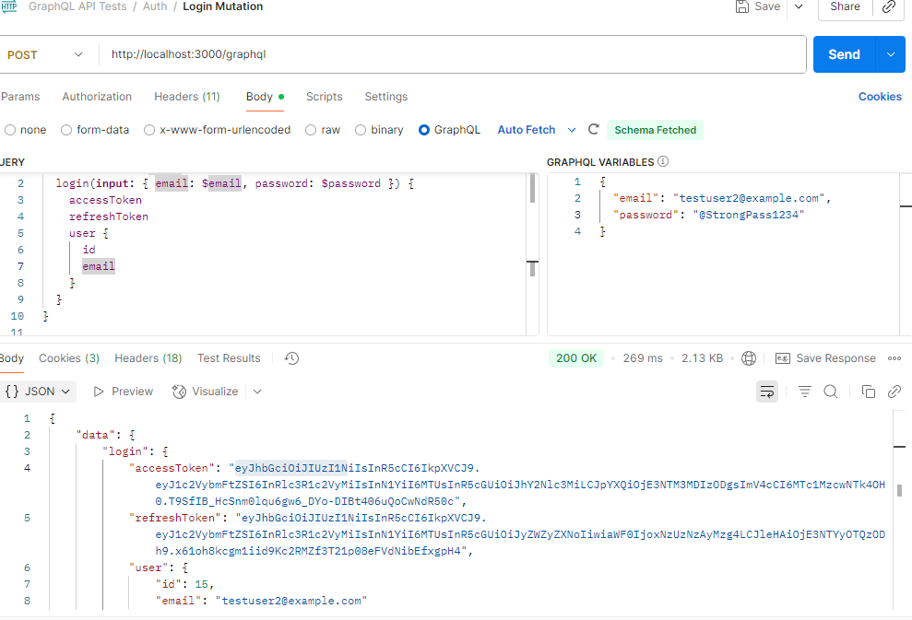

* **Cookies**

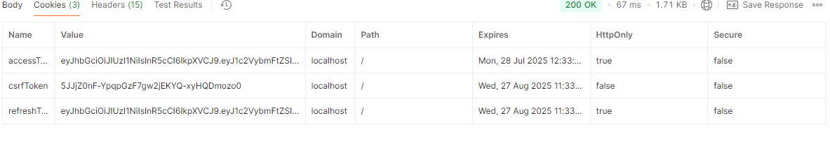

**User Testing**

* **GetCurrentUserProfile**

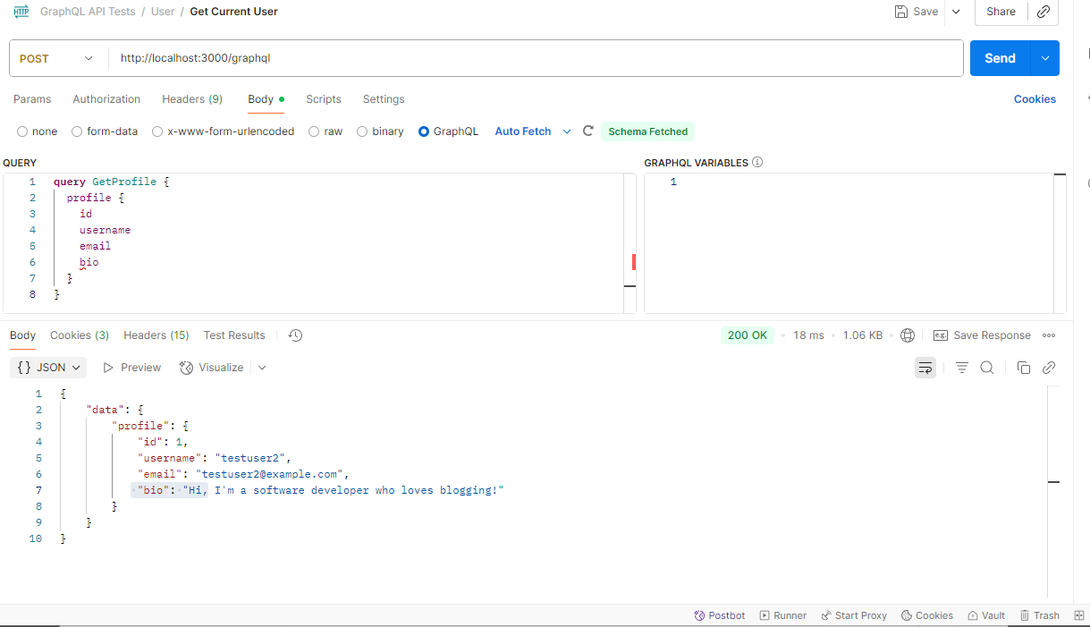

* **UpdateUserProfile**

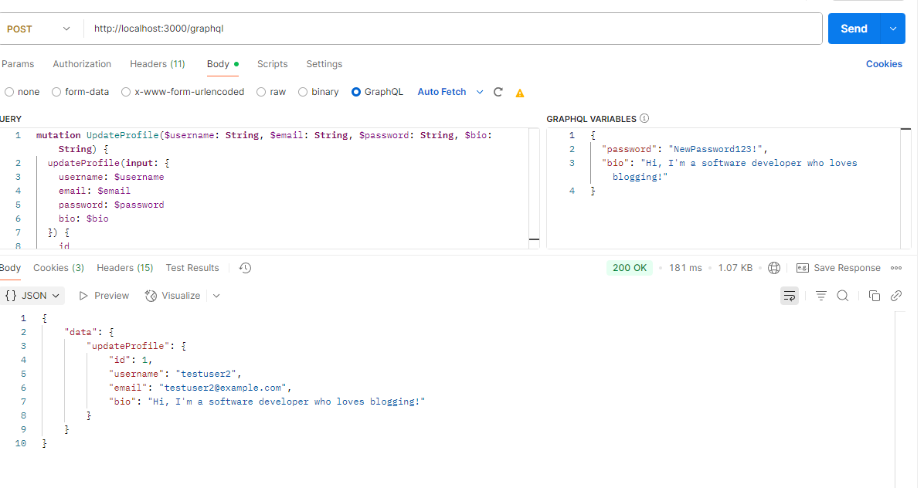

**Tags**

* **CreateTag**

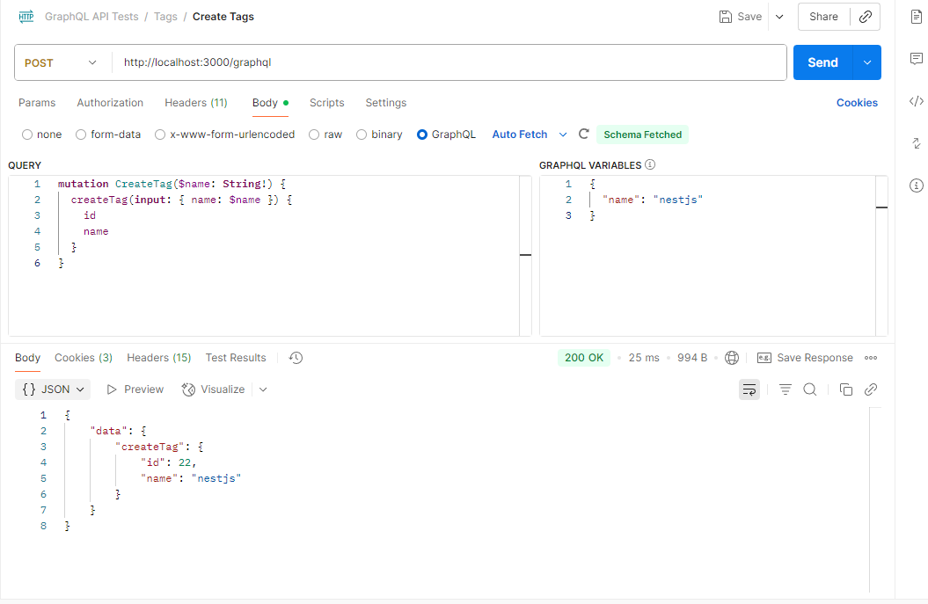

* **UpdateTags**

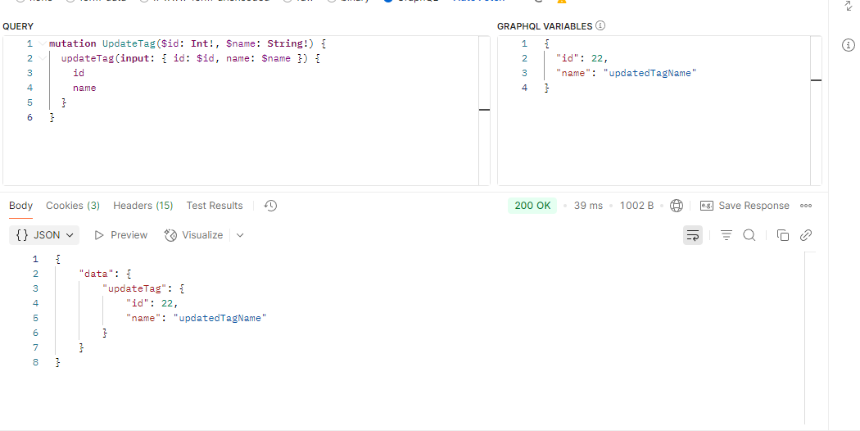

* **DeleteTags**

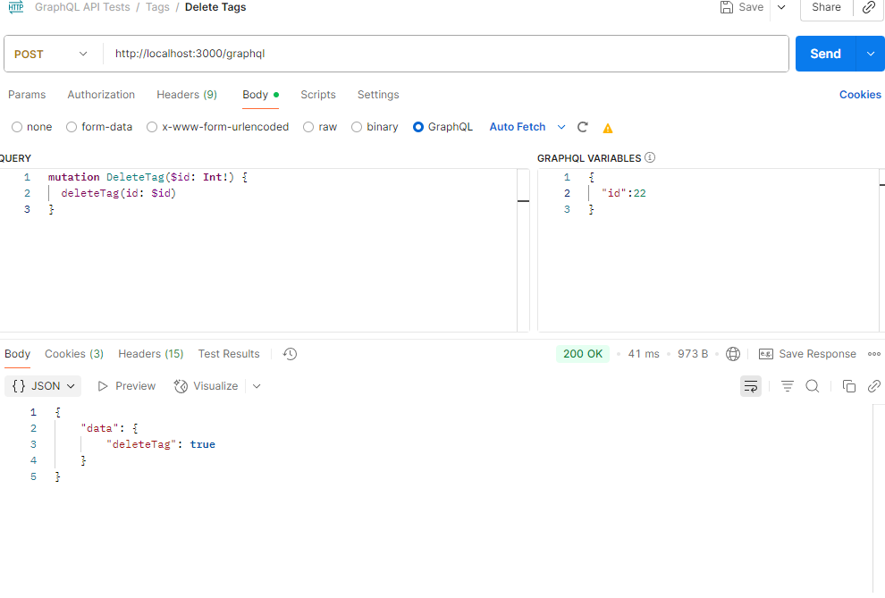

* **GetAllTags**

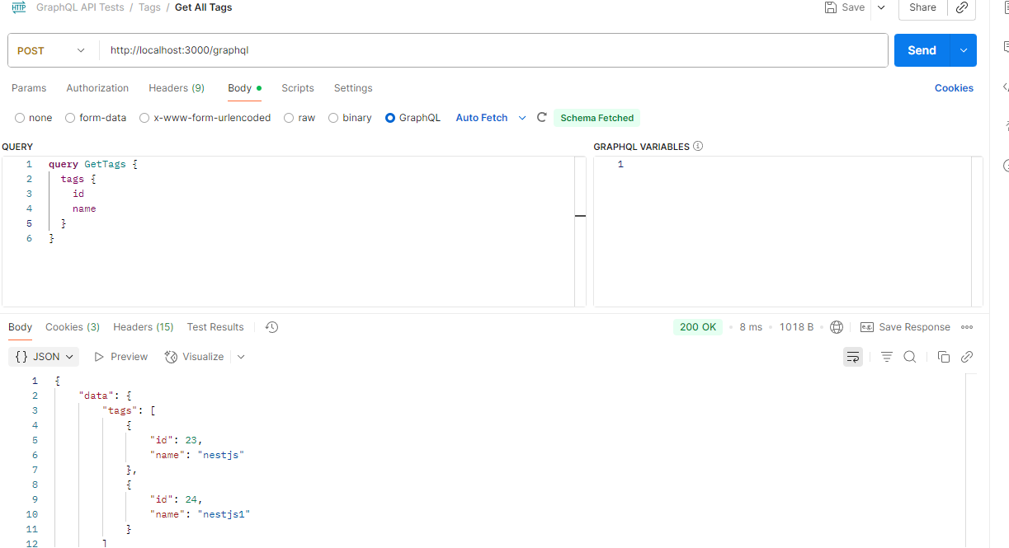

**Posts**

* **Create post for user**

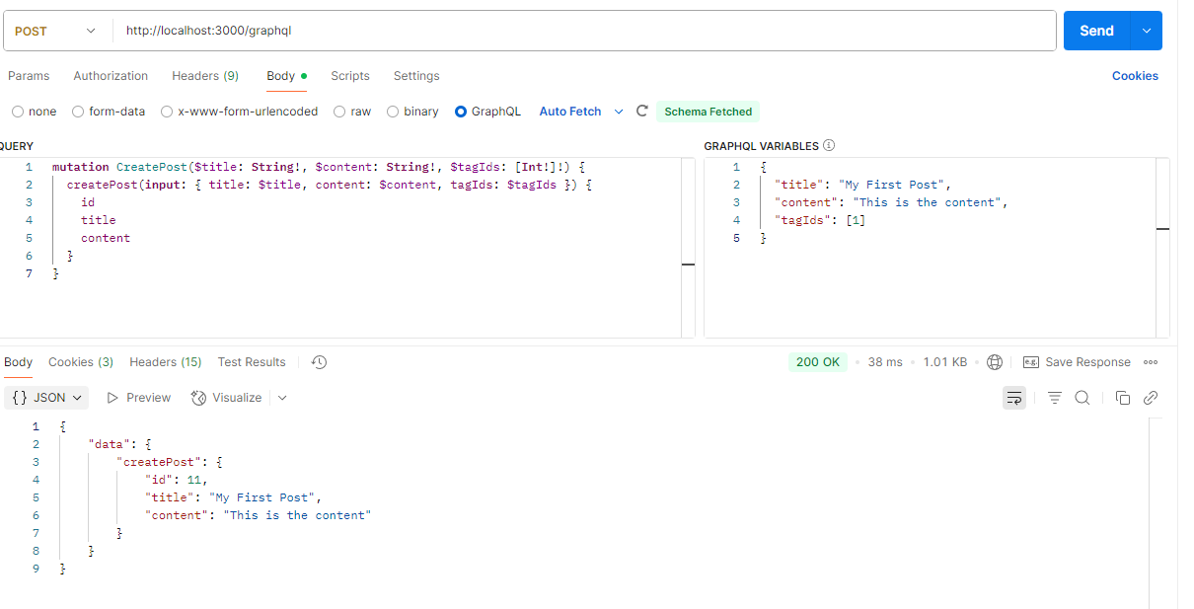

* **Update post for user**

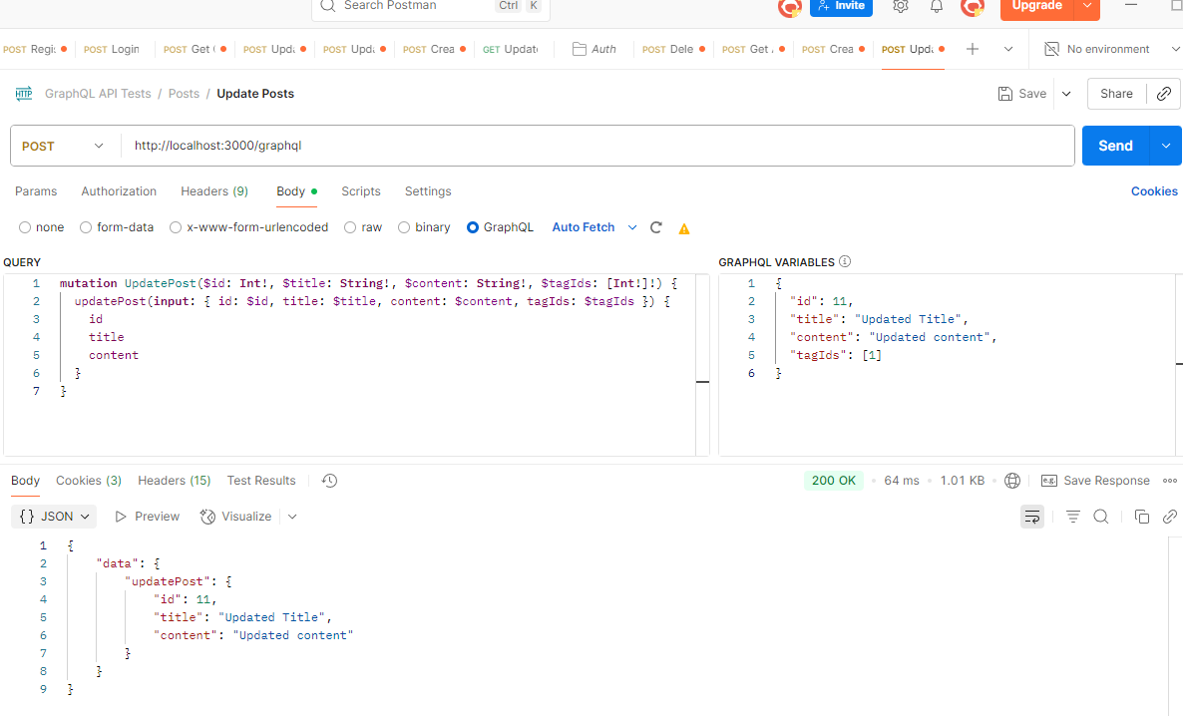

* **Delete post for user**

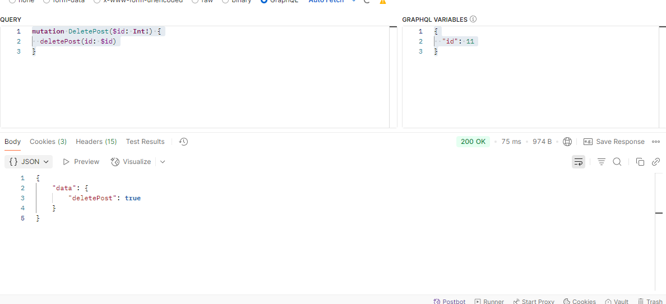

* **Get Posts By User**

